Name: Huy Minh Dinh

Student Number: 7360174

**MATH255 – Autumn 2023 Computer Lab – Week 10**

**Question 1**

1. We can complete the given two-way tables of probabilities describing Event A, B and C by calculating sums and differences for the remaining values.

|  |  |  |  |
| --- | --- | --- | --- |
|  |  |  |  |
|  |  |  |  |
|  |  |  |  |
|  |  |  |  |

|  |  |  |  |
| --- | --- | --- | --- |
|  |  |  |  |
|  |  |  |  |
|  |  |  |  |
|  |  |  |  |

|  |  |  |  |
| --- | --- | --- | --- |
|  |  |  |  |
|  |  |  |  |
|  |  |  |  |
|  |  |  |  |

1. Snapshot of the execution

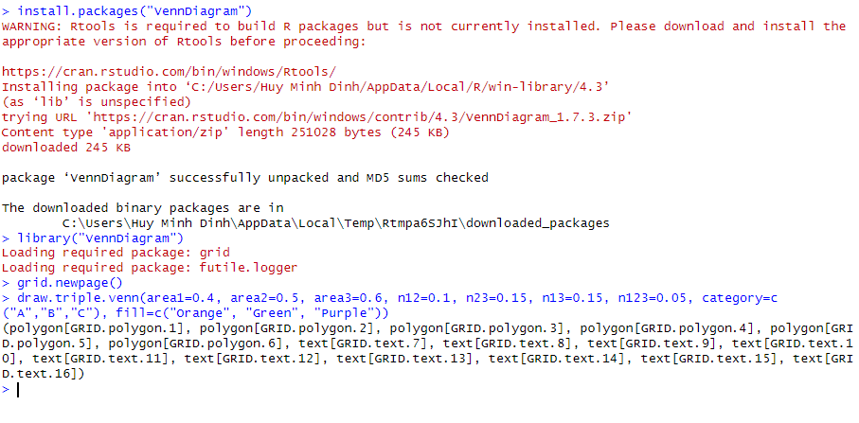

Snapshot of the generated Venn diagram

